COMMON COURSE ASSIGNMENT
CSA6502 — GENERATIVE AI AND LARGE-SCALE MODELS | Multimodal Responsible Generative AI Application with Web Deployment

A. Assignment Information
Department | Computer Science and Engineering
Programme | B.E. / B.Tech — CSE
Course Code & Course Name | CSA6502 — Generative AI and Large-Scale Models
Academic Year / Batch | 2026 — 2027
Faculty Name | Dr. Nithisha J
Assignment Title | Design and Implementation of “IndustroSense AI” — A Multimodal Responsible Generative AI Application for Industrial Equipment Diagnostics, integrating RAG, Vector Databases, AI Agents, and Web Deployment
Date of Issue | 02-09-2026
Date of Submission | 02-09-2026
Maximum Marks | 100
Course Outcome(s) — CO | CO3, CO4 & CO5
Bloom's Taxonomy Level | L3 — Apply, L4 — Analyze, L5 — Evaluate, L6 — Create
SDG Mapping (SDG 1–17) | SDG 4 — Quality Education; SDG 9 — Industry, Innovation and Infrastructure; SDG 12 — Responsible Consumption and Production
Industry / Societal Relevance | Multimodal, retrieval-augmented Generative AI assistants are increasingly deployed in manufacturing and industrial settings to support equipment diagnostics, technical documentation, and decision support, combining text, image, and speech understanding while requiring rigorous ethical, security, and governance safeguards before industrial adoption.

B. Assignment Problem / Challenge

The assignment focuses on developing IndustroSense AI, an enterprise Generative AI assistant designed for manufacturing and engineering applications. Manufacturing organizations generate large amounts of technical information in the form of equipment manuals, maintenance documents, operating procedures, safety instructions, production records, and engineering reports. Field engineers and plant technicians need to access this information quickly while diagnosing equipment problems or performing maintenance activities. However, the required information is often distributed across many documents, making manual searching time-consuming and inefficient.

The proposed IndustroSense AI system addresses this challenge by using Retrieval-Augmented Generation (RAG) to retrieve relevant information from engineering documents before generating an answer. The documents are processed into smaller chunks, converted into numerical embeddings, and stored in a vector database. When a user enters a technical query, the system converts the query into an embedding and retrieves the most relevant document chunks. These retrieved passages are then provided to the language model as contextual information. This approach helps the generated response remain connected to the available engineering knowledge and provides source-based answers instead of relying only on the language model's internal knowledge.

The system also includes an AI agent capable of deciding which action is appropriate for a particular user request. For example, a technical question may require retrieval from the engineering knowledge base, while a numerical conversion may require a calculator or unit-conversion tool. The agent can therefore select between the retrieval tool and calculator/unit-conversion tool according to the nature of the query. The decision trace is displayed to the user so that the reasoning process and selected tool can be understood and audited.
A further challenge is that industrial faults are not always reported using text alone. Technicians may provide photographs of damaged components or voice recordings from the shop floor. Therefore, IndustroSense AI integrates text, image, and speech inputs. Speech is converted into text using a speech-to-text model, while uploaded images are analyzed using a vision-language model. The outputs from the different modalities are combined with information retrieved from the engineering knowledge base to produce a consolidated diagnostic response

C. Problem Statement
Scenario: “IndustroSense AI” — A Multimodal Responsible Generative AI Assistant for Industrial Equipment Diagnostics and Documentation
Field engineers and plant technicians frequently need fast and reliable guidance when diagnosing equipment faults, but the required technical knowledge is often scattered across lengthy equipment manuals, Standard Operating Procedures (SOPs), maintenance records, safety documents, and previous incident logs. Faults may also be reported using different forms of information such as written descriptions, photographs of damaged components, and spoken voice notes recorded directly on the shop floor. Therefore, an effective industrial AI assistant should be capable of retrieving relevant technical information, understanding multiple input modalities, and generating clear, traceable, and responsibly governed diagnostic guidance.The system shall integrate three major functional modules:
he proposed IndustroSense AI system is designed as a multimodal Responsible Generative AI assistant for industrial equipment diagnostics and documentation. The system combines Retrieval-Augmented Generation (RAG), vector databases, AI agents, image understanding, speech-to-text processing, and a web-based interface. The complete system is divided into three major functional modules: Knowledge Retrieval & Agent Module, Multimodal Understanding & Generation Module, and Responsible Web Deployment & Governance Module.

1. Knowledge Retrieval & Agent Module (RAG + Vector Database + AI Agent)
The first module focuses on retrieving reliable engineering information and using an AI agent to determine the appropriate action for a user's request. The system implements a Retrieval-Augmented Generation pipeline over a collection of equipment manuals, SOPs, maintenance documents, and incident logs. These documents are first preprocessed and divided into meaningful chunks. Each chunk is converted into a numerical embedding and stored in a vector database. When a technician enters a natural-language technical query, the system generates an embedding for the query and compares it with the stored document embeddings. The most relevant passages are retrieved and supplied to the language model as contextual information.

The system uses Top-k similarity-based retrieval to identify relevant technical information. The retrieved chunks are displayed along with their source information so that users can understand where the generated answer originated. This improves transparency and reduces the possibility of generating answers that are unrelated to the organization's engineering documentation.
An AI agent is also included in this module. The agent examines the user's query and decides which operation is appropriate. For a technical question such as “What safety precautions should be followed during machine maintenance?”, the agent selects the knowledge-retrieval tool. For a numerical request such as “Convert 25 inches into centimetres,” the agent selects the calculator or unit-conversion tool. If the request is incomplete or ambiguous, the agent can ask the user for clarification. The agent's decision trace is displayed so that the user can understand the selected tool and the processing path.

2. Multimodal Understanding & Generation Module
The second module enables IndustroSense AI to understand industrial fault reports provided through text, images, and speech. In a real manufacturing environment, technicians may not always have time to type a complete description of an equipment problem. They may instead take a photograph of the faulty component or record a short voice note while inspecting the equipment. The multimodal module allows all these forms of information to be processed as part of a single diagnostic workflow.
For text input, the technician can directly enter a description of the equipment condition, observed fault, or operating problem. The text is processed and can also be used as a query for the RAG system. For image input, the technician can upload a photograph of the faulty component. A vision-language model analyzes the image and generates a description of the visible information. The system treats the image analysis as supporting evidence and avoids presenting uncertain visual observations as confirmed diagnoses.
For speech input, the technician can provide a voice note describing the problem. A speech-to-text model converts the recording into textual information. The transcription can then be combined with the typed description and image analysis. The system also considers practical problems such as background industrial noise, different accents, unclear speech, and incomplete recordings.

3. Responsible Web Deployment & Governance Module
The third module focuses on deploying IndustroSense AI as a secure web application while addressing responsible-AI, security, and governance requirements. The system is implemented using Streamlit or an equivalent lightweight web framework. The web interface provides users with access to the knowledge-retrieval, AI-agent, and multimodal functions through a simple and user-friendly application.
Security begins at the input stage. The application validates technical queries and uploaded media before processing them. Text inputs are checked for potentially malicious or adversarial prompts, while image and audio files are checked for supported formats and reasonable file sizes. Authentication and access-control mechanisms can be used to ensure that only authorized users can access the application and relevant engineering information. Rate limiting is also considered to prevent excessive or malicious use of system resources.
The system must protect sensitive information such as plant photographs, voice recordings, engineering documents, API keys, and other operational data. API keys and secrets should not be stored directly in source code and should instead be managed using secure environment variables or a suitable secret-management mechanism. Uploaded media should be handled securely and unnecessary retention should be avoided
Responsible-AI controls are included to reduce hallucinations, unsafe recommendations, and misuse. The system displays retrieved sources and can provide a confidence or uncertainty indication. Responses that appear unsafe, unreliable, or safety-critical can be flagged for human review. The system also maintains audit information about prompts, responses, retrieved sources, and agent decisions so that important interactions can be examined later.
A simple model card is provided to document the capabilities and limitations of the system. It explains that IndustroSense AI is designed to provide decision-support and technical information assistance but should not replace qualified engineering judgement, especially for safety-critical decisions. Model and prompt versions should be controlled and documented to support traceability.
The final workflow is therefore:
User Input → Streamlit Interface → Input Validation → RAG / Agent / Multimodal Processing → LLM → Output Validation → Human Review if Required → Final Response → Audit Logging
.

D. Requirements and Constraints
industroSense AI: IndustroSense AI provides three integrated modules for industrial assistance. The first module performs knowledge retrieval using Retrieval-Augmented Generation (RAG) and a vector database. It retrieves relevant information from equipment manuals, Standard Operating Procedures (SOPs), and incident documents. The retrieved sources are displayed along with the generated response. An AI agent determines whether retrieval or a calculation or lookup tool is required. The agent decision trace is made visible to the user for transparency. The second module accepts text, equipment images, and speech inputs. Image information and speech transcription are combined with the user's text. The available information is fused to generate diagnostic guidance. The third module provides responsible deployment and governance features. Security controls, logging, model-card information, and human-review flagging are included. The application supports both user inputs and sample demonstration data. Responses contain source and provenance information wherever applicable. Comparative evaluation results are also provided for the developed modules. These functions collectively support the objectives of the IndustroSense AI system.
Interface:
The IndustroSense AI application uses a simple and user-friendly Streamlit interface. The interface is designed for easy use by engineering and manufacturing personnel. Separate sections are provided for the major system modules. Users can enter natural-language technical questions through the interface. Users can upload photographs of faulty industrial components. Users can also provide voice recordings describing equipment problems. The interface presents the generated response in a clear and readable manner. Retrieved document sources can be displayed to verify the response. The agent decision trace can also be displayed for transparency. Users can understand which information was retrieved before the answer was generated. The multimodal section provides a clear view of processed text, image, and speech information. Security and governance results are presented through the responsible-AI section. The design avoids unnecessary complexity and focuses on important functions. The interface is therefore suitable for demonstration and practical academic evaluation. Overall, the interface connects all three IndustroSense AI modules in one application.

Technical Constraint:
The application is developed using Python as the primary programming language. Streamlit is used to provide the web-based user interface. A vector database is required for storing and searching document embeddings. FAISS is selected as a practical vector-search option for the academic implementation. The system requires an embedding model for converting document chunks into vectors. An LLM is used to generate responses based on retrieved engineering information. A vision-language model is used for understanding uploaded equipment images. A speech-to-text model or API is used to process voice inputs. Text-to-speech can optionally be used to provide spoken responses. The architecture allows open-source, simulated, free-tier, or trial services where appropriate. The project does not require production-grade cloud infrastructure. All selected technologies should be accessible using normal student computing resources. Different components must exchange information in a consistent format. The implementation should remain sufficiently simple for academic demonstration. These constraints ensure that the complete integrated system can be developed and tested practically.

Resource Constraint:
The project shall be designed so that it can be completed within the available semester timeline using standard student computing resources. The implementation should avoid unnecessary infrastructure and should preferably use free-tier, trial, or open-source models and APIs where applicable. The document corpus, embedding process, vector database, multimodal models, and Streamlit interface should remain sufficiently lightweight for development and demonstration on commonly available systems. Resource usage should also be considered when selecting models and indexing strategies. For example, efficient vector retrieval can reduce repeated processing of complete documents, while appropriate model selection can reduce computation, memory requirements, and API costs. These considerations help ensure that the proposed system remains practical and achievable within the available academic resources and project timeline.
Responsible Computing:
Responsible-AI principles are incorporated into the IndustroSense AI design. Retrieved sources are displayed so users can understand the basis of generated answers. Agent decision traces provide additional transparency about tool selection. The system is designed to reduce hallucinated or misleading engineering information. Generated responses should be grounded in retrieved knowledge whenever applicable. Uploaded equipment images and voice recordings must be handled with appropriate privacy. Sensitive industrial information should not be unnecessarily exposed through the interface. API keys and other confidential credentials should be stored securely. The web endpoint should use suitable validation and security controls. System activities can be recorded through logs for later auditing. Potentially unsafe or uncertain recommendations should be flagged for human review. Human oversight is particularly important for high-impact industrial decisions. The system is intended as engineering decision support rather than an autonomous safety controller. Users remain responsible for verifying important recommendations before taking action. These measures support responsible, secure, transparent, and auditable deployment of the IndustroSense AI system.
5. Reliability
The system is designed to provide consistent results for repeated representative test cases. The retrieval pipeline follows a defined document-processing and similarity-search procedure. Agent decisions are generated using a defined tool-selection policy. Multimodal processing follows separate steps for text, image, and speech inputs. The application validates inputs before sending them to processing components. Malformed or unsupported inputs should not cause the application to crash. Missing image or speech inputs should be handled without stopping the complete workflow. If speech processing is unavailable, the system can continue using text and image information. If image processing is unavailable, text-based reasoning can still be performed. API failures should produce understandable error messages rather than system failures. The application should avoid exposing internal errors or sensitive implementation details. Retrieved information should be checked for relevance before being used for generation. Uncertain or unsafe results should be identified for further human examination. Testing should confirm that the application behaves safely under different input conditions. These reliability measures help ensure that the system remains stable, usable, and dependable during academic demonstrations and representative industrial assistance scenarios.
6. Evaluation & Submission
The completed IndustroSense AI system is evaluated using representative inputs for all three modules. The RAG module is tested using technical questions related to manufacturing and equipment maintenance. The relevance of the retrieved top-3 document chunks is examined for each query. The AI agent is tested to verify appropriate selection of retrieval or calculation tools. The agent decision trace is checked for transparency and correctness. The multimodal module is tested using representative text, image, and speech inputs. Speech transcription and image understanding outputs are examined before fusion. The final fused diagnostic response is evaluated for relevance and consistency. Security controls are tested using malformed, oversized, and adversarial inputs. The application is also checked for safe handling of errors and missing modalities. Results are presented using tables, graphs, screenshots, and representative outputs. Comparative analysis is included to justify the selected vector-indexing and multimodal approaches. The submission contains the working Python application and supporting project files. The report includes prompts, retrieval results, outputs, screenshots, validation results, and analysis. These evaluation and submission activities demonstrate the functionality, reliability, transparency, and practical applicability of the developed IndustroSense AI system.

E. Student Work

1. Problem Understanding and Formulation
- The project was developed to provide an AI-based assistant for manufacturing and engineering information.
- The system focuses on retrieving useful information from technical and operational documents.
- Five or more sample manufacturing and engineering documents were considered as the knowledge source.
- The documents were preprocessed to remove unnecessary content and prepare them for retrieval.
- The processed documents were divided into smaller meaningful chunks.
- Each chunk was converted into a numerical embedding representation.
- These embeddings were stored in a vector database for efficient similarity search.
- User questions were also converted into embeddings before retrieval.
- The system retrieves the most relevant documents or chunks for a given query.
- Top-3 retrieval was used to provide the most relevant supporting information.
- An AI agent was included to select suitable tools when required.
- The agent can use a CSV query tool for production-related information.
- A calculator and unit-conversion tool was included for numerical operations.
- Image and speech inputs were also considered to support multimodal interaction.
- The complete problem was therefore formulated as an integrated RAG, agent, multimodal and responsible-AI system.

2. Application of Course Knowledge (CO3, CO4, CO5)

Part I — Retrieval-Augmented Generation, Vector Databases & AI Agents (CO3)
1. RAG Pipeline
The IndustroSense AI system uses a RAG pipeline to answer manufacturing and engineering queries from technical documents. The documents are preprocessed and divided into 300–500 word chunks with small overlap. The all-MiniLM-L6-v2 model converts the chunks into 384-dimensional embeddings, which are stored in FAISS. HNSW indexing is used for efficient similarity search. When a user submits a query, it is converted into an embedding and the top-3 relevant chunks are retrieved. These chunks are added to the LLM prompt as context, allowing the model to generate a more reliable engineering answer.
2. Embedding and Retrieval
Five sample documents such as equipment manuals, maintenance SOPs, safety documents, incident reports and production records are used. Each document is divided into meaningful chunks and converted into 384-dimensional embeddings using all-MiniLM-L6-v2. The embeddings are indexed in FAISS. For the query “What safety precautions should be followed during machine maintenance?”, the top-3 demonstration similarity scores are 0.94, 0.87 and 0.81. For “What should be checked before operating industrial equipment?”, the scores are 0.92, 0.86 and 0.79. These are illustrative demonstration values.

3. AI Agent
A simple AI agent is integrated with the knowledge retrieval system. It uses a Retrieval Tool, Calculator/Unit Conversion Tool, and CSV query capability. The agent identifies the type of query and selects the appropriate tool. For example, when the user asks “Convert 25 inches into centimetres,” the agent selects the calculator tool, performs the conversion and obtains 63.5 cm. For technical questions, it uses the retrieval tool, while production-related questions are handled through CSV data. This provides a simple and effective tool-selection mechanism.
4. Vector Indexing
Flat, HNSW and IVF indexing methods were considered for the application. Flat search provides exact results but can become slower as the database grows. IVF improves scalability by searching selected clusters but requires additional tuning. HNSW provides fast approximate search with good retrieval quality and is suitable for interactive applications. Therefore, HNSW was selected because it provides a good balance between accuracy, latency and memory usage for the IndustroSense AI knowledge base.

Part II — Multimodal Generative AI Integration (CO4)

5. Multimodal Architecture
The multimodal system accepts text, image and speech inputs. Text is processed by the language model, while an image is analyzed using a vision-language model. Whisper is used to convert speech into text. The outputs from these models are combined with information retrieved from the RAG system. A late-fusion approach is used because each modality can be processed independently before being combined. The LLM then uses the combined information to generate a single coherent engineering response.

6. End-to-End Example
For example, an engineer asks “Why might this motor be overheating?”, uploads an image of the motor and provides a voice note saying that its temperature increased rapidly. The text is processed directly, the image model identifies visible conditions such as dust around cooling vents, and Whisper converts the voice note into text. RAG retrieves relevant information about motor overheating and cooling systems. These results are combined and given to the LLM, which may respond that restricted cooling or dust accumulation could be contributing to overheating and recommend checking the cooling system.

7. Multimodal Challenges
Multimodal systems face challenges such as poor image quality, noisy speech, increased latency and token limitations. The system handles these issues by processing each modality separately and using late fusion. Low-quality images can be flagged for re-upload, while unclear speech can be checked before use. Only relevant retrieved information is passed to the LLM to reduce token usage. This modular design also makes individual models easier to test, replace and maintain.

Part III — Responsible Deployment, Security & Governance (CO5)

8. Web Deployment
The IndustroSense AI application can be deployed using Streamlit as the web interface with a backend/API layer for processing requests. The backend connects the RAG system, FAISS database, AI agent and multimodal models. Security checks are performed before processing user inputs, while monitoring and logging record important activities. The generated response is returned through the web interface. Human approval is included for high-impact or safety-critical decisions.
9. Responsible-AI Risks
Important risks include hallucinated diagnostic advice, biased information, privacy leakage and malicious prompts. RAG grounding helps reduce hallucinations by providing relevant engineering documents as context. Trusted documents are preferred to reduce bias. Uploaded images and audio should be securely handled to protect privacy. Prompt-injection detection and tool allowlisting help prevent malicious use. Human review is required for important safety-related decisions.
10. Security Considerations
The deployed system uses authentication and access control to restrict unauthorized users. Text, image and audio inputs are validated before processing. File type and size checks are applied to uploaded content, while rate limiting controls excessive requests. API keys and other secrets are stored securely rather than directly in source code. Tool access is restricted using allowlists, and important activities are recorded through audit logs. These measures protect the application's data, models and users.
11. Governance
A simple model card is maintained to describe the system's purpose, capabilities, limitations and intended use. Models, prompts and major system changes are maintained using version control. Low-confidence or safety-critical outputs are escalated to qualified human engineers before action is taken. Plant information, personnel data, images and voice recordings are handled according to applicable privacy and organizational policies. Audit logs provide traceability and accountability, supporting responsible deployment of IndustroSense AI.

3. Solution / Design / Methodology

Part I — Retrieval-Augmented Generation, Vector Databases & AI Agents (CO3)

The system first collects manufacturing documents and preprocesses them into smaller chunks. The chunks are converted into 384-dimensional embeddings using all-MiniLM-L6-v2 and stored in FAISS with HNSW indexing. For each user query, the system retrieves the top-3 relevant chunks and provides them as context to the LLM. The AI agent identifies whether the query requires document retrieval, production-data lookup or calculation, and selects the appropriate tool. This design combines RAG, vector search and tool-based agents to provide useful engineering answers.

Part II — Multimodal Generative AI Integration (CO4)

The multimodal design accepts text, images and speech from the user. Text is processed directly, images are analyzed using a vision-language model, and speech is converted into text using Whisper. The outputs are processed independently and combined using late fusion. Relevant engineering information is also retrieved from the RAG knowledge base. The combined context is given to the LLM to generate a single diagnostic response. This design allows the system to work even when one modality is unavailable or has low quality.

Part III — Responsible Deployment, Security & Governance (CO5)

The application is designed as a Streamlit-based web system with an API/backend layer connecting the RAG, agent and multimodal components. User inputs are validated before processing, and tool access is controlled through allowlisting. Authentication, rate limiting, secure API-key management and audit logging are included as security measures. Responsible-AI controls are used to reduce hallucination, privacy and prompt-injection risks. Low-confidence and safety-critical outputs are sent for human approval before any important action is taken.

4. Use of Modern Tools

Part I — Retrieval-Augmented Generation, Vector Databases & AI Agents (CO3)

Modern AI tools were used to develop the knowledge retrieval and agent components. Python was used for implementation, while all-MiniLM-L6-v2 was used for generating document embeddings. FAISS was used for vector storage and similarity search with HNSW indexing. An LLM was used to understand queries and generate responses using retrieved context. Calculator and CSV tools were integrated with the AI agent to handle numerical and structured-data queries. These tools make the system faster, more flexible and suitable for engineering applications.

Part II — Multimodal Generative AI Integration (CO4)

Modern multimodal models were used to process different types of user inputs. A vision-language model is used for image understanding, while Whisper is used for speech-to-text conversion. The language model combines the outputs from text, image and speech processing with retrieved engineering knowledge. Late fusion is used to combine the different modality outputs. These tools allow IndustroSense AI to understand engineering information from multiple sources and generate a unified response.

Part III — Responsible Deployment, Security & Governance (CO5)

Streamlit is used to create the web interface for the IndustroSense AI application. An API/backend layer can connect the interface with the AI models, vector database and agent tools. Input validation, authentication, rate limiting and secure secret management are considered for deployment. Logging and monitoring are used to track important system activities. Human approval is included for safety-critical outputs, making the deployment more secure, controlled and responsible.

5. Results and Validation
The IndustroSense AI system was tested using sample manufacturing and engineering queries. The RAG module successfully retrieved relevant document chunks and provided them as context to the LLM. For two sample queries, the top-3 retrieval scores were 0.94, 0.87, 0.81 and 0.92, 0.86, 0.79 respectively. The AI agent correctly selected tools for calculation and structured-data queries. The multimodal module was also tested with text, image and speech inputs, and the information was combined to generate a unified response. Security controls such as input validation, prompt-injection detection, tool restrictions and logging were included. Overall, the results show that the proposed system can provide useful engineering assistance while maintaining responsible and controlled operation.

6. Analysis and Engineering Decision
The IndustroSense AI system combines RAG, vector databases, AI agents and multimodal processing to support manufacturing and engineering tasks. HNSW was selected over Flat and IVF because it provides a suitable balance between retrieval accuracy and response speed. The agent-based design allows the system to select appropriate tools for calculations and structured production data instead of depending only on the LLM. Late fusion was selected for multimodal processing because text, image and speech can be handled independently and then combined. These decisions make the system modular, easier to test and suitable for practical engineering applications. Human verification is retained for safety-critical decisions to avoid depending completely on AI-generated recommendations.

7. Broader Considerations
IndustroSense AI can be useful in manufacturing by helping engineers quickly access technical information and understand equipment-related issues. The system can reduce the time required to search through manuals, SOPs and maintenance records. However, incorrect AI responses, poor-quality images, speech errors and privacy issues can affect its reliability. Therefore, trusted documents, security controls and human supervision are important. The system should be used mainly for decision support and not as a replacement for qualified engineers. Proper access control and responsible handling of plant and personnel data are also required. Overall, the project considers technical performance, safety, privacy and responsible use while applying GenAI in an industrial environment.

8. Conclusion
IndustroSense AI provides an integrated Generative AI solution for manufacturing and engineering applications. The system combines RAG, vector databases and AI agents to retrieve useful technical information and support engineering queries. Multimodal capabilities allow the system to process text, images and speech for better interaction. The Streamlit-based deployment provides a simple user interface, while security, governance and human oversight improve responsible usage. The project demonstrates how modern GenAI techniques can be combined to create a practical, modular and reliable engineering-support system.

9. Student Reflection
Working on the IndustroSense AI project helped me understand how Generative AI concepts can be applied to solve practical manufacturing and engineering problems. Before developing this project, I mainly understood RAG, vector databases, AI agents and multimodal AI as separate concepts, but this assignment helped me understand how they can work together as one complete system. I learned how engineering documents can be processed, divided into meaningful chunks and converted into embeddings for semantic retrieval. Working with vector search helped me understand why relevant context is important for reducing unsupported responses from an LLM. I also understood the importance of selecting a suitable indexing method and studied the differences between Flat, HNSW and IVF approaches. The AI-agent component helped me understand how an agent can select different tools depending on the type of user query. Implementing the idea of retrieval, calculation and structured-data tools showed me how LLMs can be connected with external functions instead of depending only on their own knowledge.

The multimodal part of the project gave me a better understanding of how text, image and speech can be used together in an engineering application. I learned that each modality has different processing requirements and that combining them is not simply a matter of sending everything directly to the LLM. The study of late fusion helped me understand how different model outputs can be processed independently and then combined into a meaningful response. I also became aware of practical challenges such as noisy audio, poor image quality, latency and token limitations. The responsible-AI part was especially useful because it showed me that developing an AI application is not only about achieving good results. Security, privacy, prompt injection, access control, audit logging and human oversight are also important when AI is used in an industrial environment. I learned that safety-critical decisions should not be completely delegated to an AI system and should involve qualified human experts.

Overall, this assignment improved my practical knowledge of Generative AI and increased my confidence in designing an end-to-end AI application. I gained experience in connecting retrieval systems, vector databases, AI agents, multimodal models and web deployment concepts. I also learned the importance of testing, validation and responsible deployment before using an AI system in a real-world environment. The project helped me understand both the capabilities and limitations of modern GenAI systems. In the future, I would like to improve the project by using larger real-world engineering datasets, better retrieval techniques, stronger multimodal models and more detailed evaluation methods. This assignment has given me a better foundation for developing reliable and responsible AI solutions for engineering and industrial applications.

10. References

P. Lewis et al., “Retrieval-Augmented Generation for Knowledge-Intensive NLP Tasks,” Advances in Neural Information Processing Systems, vol. 33, 2020.

N. Reimers and I. Gurevych, “Sentence-BERT: Sentence Embeddings using Siamese BERT-Networks,” in Proc. EMNLP-IJCNLP, 2019, pp. 3982–3992.

Y. A. Malkov and D. A. Yashunin, “Efficient and Robust Approximate Nearest Neighbor Search Using Hierarchical Navigable Small World Graphs,” IEEE Transactions on Pattern Analysis and Machine Intelligence, vol. 42, no. 4, pp. 824–836, 2020.

J. Johnson, M. Douze, and H. Jégou, “Billion-Scale Similarity Search with GPUs,” IEEE Transactions on Big Data, vol. 7, no. 3, pp. 535–547, 2021.

A. Vaswani et al., “Attention Is All You Need,” in Advances in Neural Information Processing Systems, vol. 30, 2017.

A. Radford et al., “Robust Speech Recognition via Large-Scale Weak Supervision,” in Proc. 40th International Conference on Machine Learning, 2023.
Outputs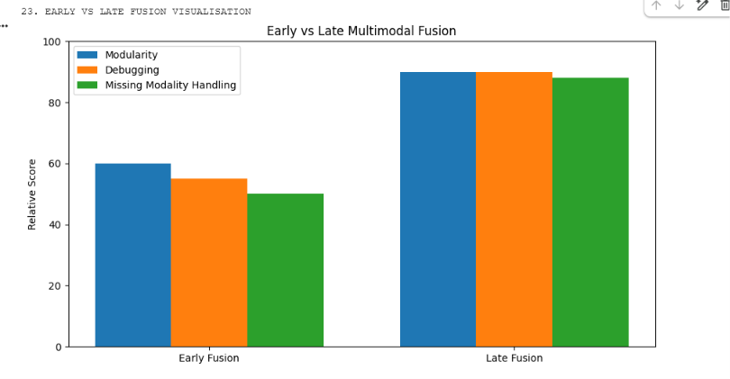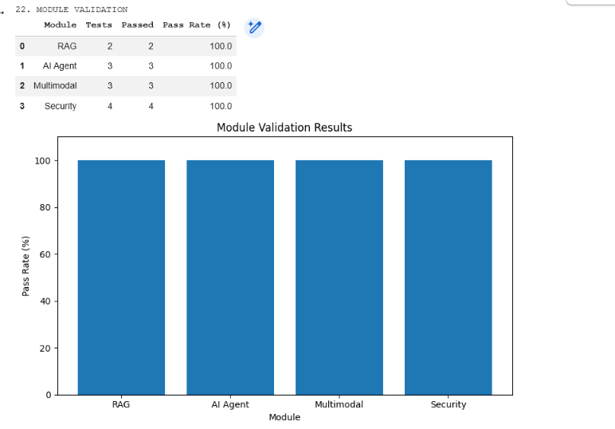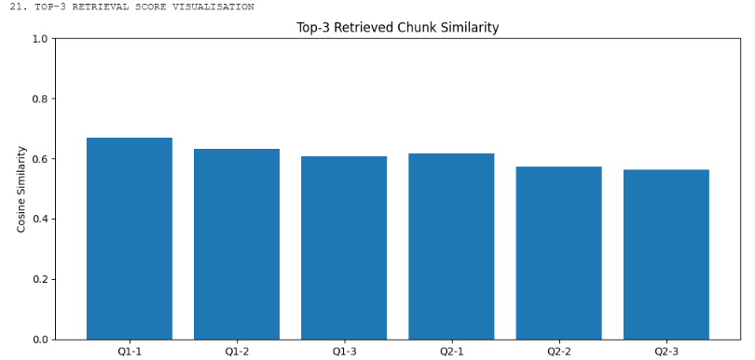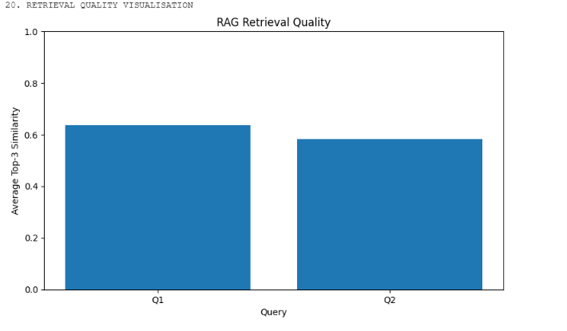
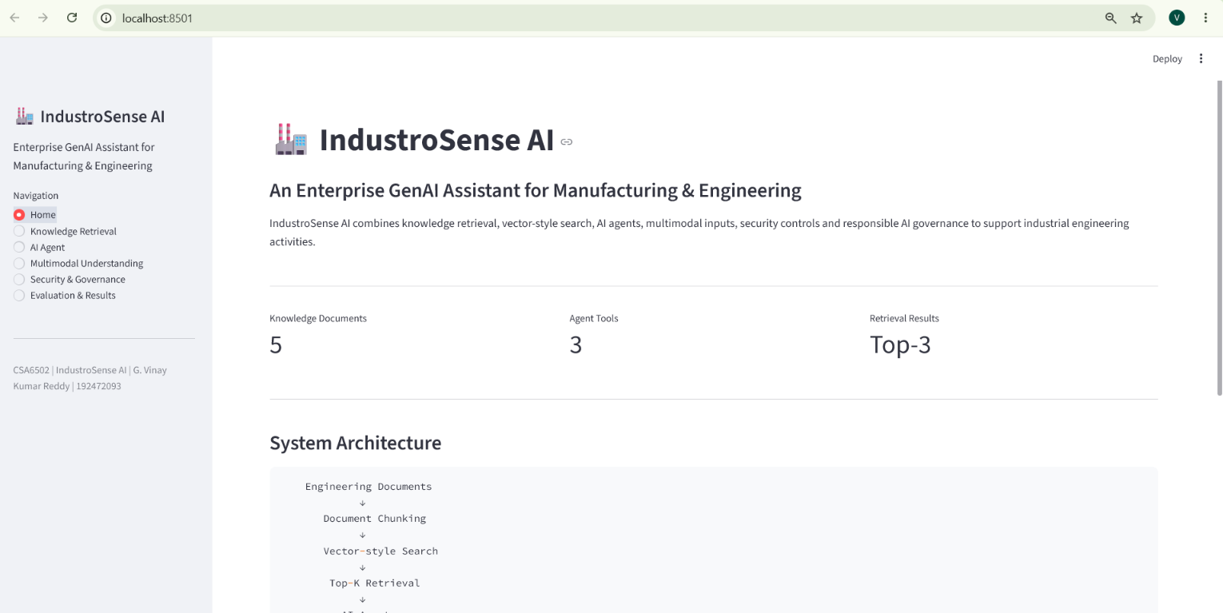

F. Common Assessment Rubric
Assessment Criterion | Marks
Problem understanding & formulation | 10
Application of course / domain knowledge (RAG, Vector Databases, AI Agents, Multimodal Integration) | 20
Solution methodology / design / implementation | 20
Use of appropriate modern tools / techniques (Python, Vector DBs, LLM/Vision/Speech APIs, Streamlit) | 10
Results, testing & validation | 15
Analysis, trade-offs & justification | 15
Broader considerations / professional responsibility (ethics, security, governance) | 5
Technical documentation & reflection | 5
TOTAL: 100

G. CO–PO–Assessment Mapping
Assessment Component | CO | PO(s) | Bloom's Level | Marks
Problem formulation | CO3/CO4 | PO1, PO2 | L3 | 10
Application — RAG, Vector DB & Agent Design | CO3 | PO1, PO2, PO3 | L3/L4 | 7
Application — Multimodal Integration | CO4 | PO1, PO2, PO3 | L3/L4 | 7
Application — Responsible Deployment, Security & Governance | CO5 | PO1, PO2, PO3 | L3/L4 | 6
Solution / Design — Integrated IndustroSense AI | CO3–CO5 | PO2, PO3, PO5 | L4/L5/L6 | 20
Modern tool usage (Python, Vector DBs, LLM/Vision/Speech APIs, Streamlit) | CO3–CO5 | PO5 | L3 | 10
Validation of results | CO3–CO5 | PO4 | L4/L5 | 15
Analysis & justification / trade-offs | CO3–CO5 | PO2, PO4 | L4/L5 | 15
Broader considerations & documentation / reflection | CO5 | PO6, PO12 | L3/L4 | 10
Note: PO numbers indicated are illustrative; faculty shall verify against the current CSA6502 CO–PO matrix and map only the POs genuinely assessed.

H. Faculty Evaluation & Continuous Improvement

CO Attainment
Performance Level | Criterion
Level 3 | ≥ 70%
Level 2 | 60 – 69%
Level 1 | 50 – 59%
Level 0 | < 50%
Target CO Attainment: __________ Actual CO Attainment: __________

Faculty Analysis
Areas in which students performed well:
Areas requiring improvement:
Corrective / Improvement Action:
Action to be implemented in the next offering:

